Rc-minerals and fossils for Identification

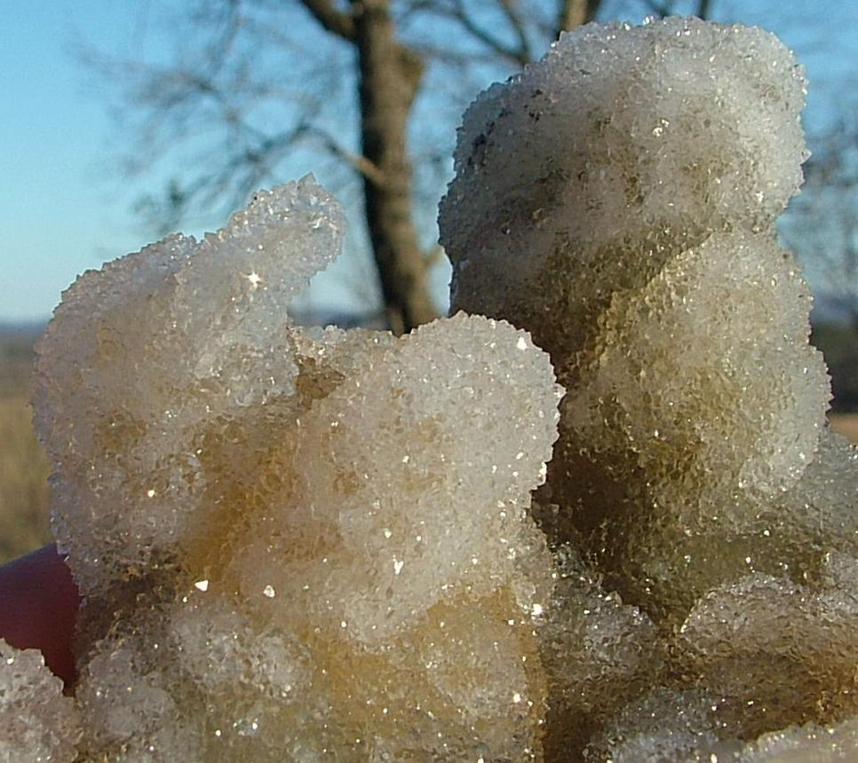

# Agatized Fossil Coral, Lowndes County Georgia

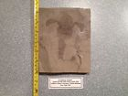

[Eurypterus remipes Fossil Upper Silurian - New York](http://www.ebay.com/itm/151913109924?_trksid=p2057872.m2749.l2649&ssPageName=STRK%3AMEBIDX%3AIT)

( 151913109924 )

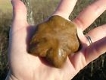

[Cambrian fossil "Brooksella" Floyd Co. Georgia](http://www.ebay.com/itm/151906903554?_trksid=p2057872.m2749.l2649&ssPageName=STRK%3AMEBIDX%3AIT)

( 151906903554 )

Delivered on Fri, Dec 18

# 

|  |  |  |
| --- | --- | --- |
| [Add note](javascript:;) | ITEM PRICE:  US $237.06 |  |

|  |  |
| --- | --- |
| ORDER DATEDec 12, 2015 | ORDER TOTAL  US $150.00  + US $15.00  shipping  **Order Eurypterus remipes Fossil Upper Silurian - New York** [Leave feedback - ORDER DATE Dec 12, 2015](http://feedback.ebay.com/ws/eBayISAPI.dll?LeaveFeedbackShow&useridto=rubycon1111&transactID=1341672159005&item=151913109924&_trksid=p2057872.m2749.l2665)[View order details](http://payments.ebay.com/ws/eBayISAPI.dll?ViewPaymentStatus&transId=1341672159005&itemid=151913109924&_trksid=p2057872.m2749.l2673) - ORDER DATE Dec 12, 2015  [More actions - ORDER DATE Dec 12, 2015](http://www.ebay.com/myb/PurchaseHistory) |

1 item sold by [rubycon1111](http://www.ebay.com/usr/rubycon1111?_trksid=p2057872.m2749.l2754)

|  |  |
| --- | --- |
| [Eurypterus remipes Fossil Upper Silurian - New York](http://www.ebay.com/itm/151913109924?_trksid=p2057872.m2749.l2649&ssPageName=STRK%3AMEBIDX%3AIT)  ( 151913109924 )  Delivered on Wed, Dec 16  Tracking number: [**Tracking number**9405509699938034605093](javascript:;)  [Add note](javascript:;) | ITEM PRICE: |

|  |  |  |  |  |
| --- | --- | --- | --- | --- |
| [Very Rare Chinese Best Triassic Keichousaurus Real Turtle Fossil FREE SHIPPING](http://www.ebay.com/itm/191754591720?_trksid=p2057872.m2749.l2649&ssPageName=STRK%3AMEBIDX%3AIT)  ( 191754591720 )  Delivered on Wed, Dec 23  Tracking number: [**Tracking number**LK715995135CN](javascript:;)  [Add note](javascript:;) | | | | ITEM PRICE:  US $110.50 |
|  | ORDER DATEDec 11, 2015 | ORDER TOTAL  US $29.95  + US $7.50  shipping  **Order Madagascar Sand Dollar Jurassic Fossil SIMPLY AWESOME!!** [Leave feedback - ORDER DATE Dec 11, 2015](http://feedback.ebay.com/ws/eBayISAPI.dll?LeaveFeedbackShow&useridto=sharksteeth_com&transactID=1220204748014&item=331167533421&_trksid=p2057872.m2749.l2665)[View order details](http://payments.ebay.com/ws/eBayISAPI.dll?ViewPaymentStatus&transId=1220204748014&itemid=331167533421&_trksid=p2057872.m2749.l2673) - ORDER DATE Dec 11, 2015  [More actions - ORDER DATE Dec 11, 2015](http://www.ebay.com/myb/PurchaseHistory) |  | |

1 item sold by [sharksteeth_com](http://www.ebay.com/usr/sharksteeth_com?_trksid=p2057872.m2749.l2754)

|  |  |  |  |
| --- | --- | --- | --- |
| [Madagascar Sand Dollar Jurassic Fossil SIMPLY AWESOME!!](http://www.ebay.com/itm/331167533421?_trksid=p2057872.m2749.l2649&ssPageName=STRK%3AMEBIDX%3AIT)  ( 331167533421 )  Delivered on Sun, Dec 20  Tracking number: [**Tracking number**9405909699939524119319](javascript:;) | | |  |
|  | ORDER DATEDec 11, 2015 | ORDER TOTAL  US $17.00  + US $4.00  shipping  **Order A perfect Lepidostrobophyllum hastatus from Mazon Creek Fossils site ~ pit 11** [Leave feedback - ORDER DATE Dec 11, 2015](http://feedback.ebay.com/ws/eBayISAPI.dll?LeaveFeedbackShow&useridto=cliffattack&transactID=0&item=361444657276&_trksid=p2057872.m2749.l2665)[View order details](http://payments.ebay.com/ws/eBayISAPI.dll?ViewPaymentStatus&transId=0&itemid=361444657276&_trksid=p2057872.m2749.l2673) - ORDER DATE Dec 11, 2015  [More actions - ORDER DATE Dec 11, 2015](http://www.ebay.com/myb/PurchaseHistory) | |

1 item sold by [cliffattack](http://www.ebay.com/usr/cliffattack?_trksid=p2057872.m2749.l2754)

|  |
| --- |
| [A perfect Lepidostrobophyllum hastatus from Mazon Creek Fossils site ~ pit 11](http://www.ebay.com/itm/361444657276?_trksid=p2057872.m2749.l2649&ssPageName=STRK%3AMEBIDX%3AIT)  ( 361444657276 )  Delivered on Mon, Dec 21  Tracking number: [**Tracking number**9500111935945352240132](javascript:;) |

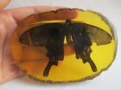

[10.6 cm * / China collection.Amber natural butterfly statue](http://www.ebay.com/itm/221940576311?_trksid=p2057872.m2749.l2649&ssPageName=STRK%3AMEBIDX%3AIT)

( 221940576311 )

Delivered on Sat, Dec 26

Tracking number: [**Tracking number**LK718640140CN](javascript:;)

|  |  |
| --- | --- |
| ORDER DATENov 30, 2015 | ORDER TOTAL  US $99.00  + US $35.00  shipping  **Order CRIMSON RED REALGAR on ORPIMENT & QUARTZS from PERU - FINE MASTER PIECE** [Leave feedback - ORDER DATE Nov 30, 2015](http://feedback.ebay.com/ws/eBayISAPI.dll?LeaveFeedbackShow&useridto=rcfineart&transactID=0&item=361436886849&_trksid=p2057872.m2749.l2665)[View order details](http://payments.ebay.com/ws/eBayISAPI.dll?ViewPaymentStatus&transId=0&itemid=361436886849&_trksid=p2057872.m2749.l2673) - ORDER DATE Nov 30, 2015  [More actions - ORDER DATE Nov 30, 2015](http://www.ebay.com/myb/PurchaseHistory) |

1 item sold by [rcfineart](http://www.ebay.com/usr/rcfineart?_trksid=p2057872.m2749.l2754)

|  |
| --- |
| [CRIMSON RED REALGAR on ORPIMENT & QUARTZS from PERU - FINE MASTER PIECE](http://www.ebay.com/itm/361436886849?_trksid=p2057872.m2749.l2649&ssPageName=STRK%3AMEBIDX%3AIT)  ( 361436886849 )  Delivered on Mon, Dec 21 |

tem sold by [ecclecticcollectorj](http://www.ebay.com/usr/ecclecticcollectorj?_trksid=p2057872.m2749.l2754)

|  |
| --- |
| [Very Rare Red Heulandite Prospect Park NJ Natural Mineral Display Specimen C5](http://www.ebay.com/itm/201473399341?_trksid=p2057872.m2749.l2649&ssPageName=STRK%3AMEBIDX%3AIT)  ( 201473399341 )  Delivered on Wed, De |